Environmental factors activity

Equipment required: Name_____________

A3 paper and stationary

* Use Figure 7 on page 425 from your Jacaranda textbook.
* Investigate how Mexico or a country in West Africa or Eastern Europe could improve the sustainability of its agriculture.
* 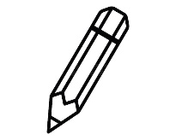Create a mind map or flow chart diagram
* Present your findings

Environmental factors activity

Equipment required: Name_____________

A3 paper and stationary

* Use Figure 7 on page 425 from your Jacaranda textbook.
* Investigate how Mexico or a country in West Africa or Eastern Europe could improve the sustainability of its agriculture.
* Create a mind map or flow chart diagram
* Present your findings

Environmental factors activity

Equipment required: Name_____________

A3 paper and stationary

* Use Figure 7 on page 425 from your Jacaranda textbook.
* Investigate how Mexico or a country in West Africa or Eastern Europe could improve the sustainability of its agriculture.
* Create a mind map or flow chart diagram
* Present your findings